INSERT HERE THE TITLE (16pt)
INSIRA AQUI O TÍTULO (14pt)
Author 1*ª, Author 2^{b} e Author 3^{c}(12pt)
ªAffiliation of Author 1 (10pt)
E-mail: author1@affiliation.com
^{b}Affiliation of Author 2
E-mail: author2@affiliation.com
^{c}Affiliation of Author 3
E-mail: author3@affiliation.com
*Corresponding author
ABSTRACT (200 words)
This document contains the guidelines for preparing the abstract to be submitted to the Scientific Committee of the II Brazilian Conference of Steel and Composite Structures (CBEMM26). According to ABNT NBR 6028:2021 recommendations, the abstract must be written in a sequence of concise sentences in a single paragraph. The font used is Arial, size 10pt, with single spacing between lines. In the abstract, the authors will present the object of study, problem, aims, methodology and main findings or expected results.
Keywords: Word1; Word2; Word3; Word4; Word5.

RESUMO (200 palavras)
Este documento contém as diretrizes para a elaboração do resumo a ser submetido para o Comitê Científico do II Congresso Brasileiro de Estruturas Metálicas e Mistas (CBEMM26). Conforme recomendações da ABNT NBR 6028:2021, o resumo deverá ser escrito por uma sequência de frases concisas em um único parágrafo. A fonte utilizada é a Arial, de tamanho 10pt, com espaçamento simples entre as linhas. No resumo, os autores apresentarão o objeto de estudo, problemática, objetivos, metodologia e principais conclusões ou resultados esperados.
Palavras-chave: Palavra1; Palavra2; Palavra3; Palavra4; Palavra5.

- INTRODUCTION
The article must present content that fits within the Thematic Areas listed on the website of the II Brazilian Conference on Steel and Composite Structures (CBEMM26). The scientific research content may be developed in a maximum of ten pages, following this template. Spacing of 10pt, before and after, must be applied to sections and subsections titles. Authors must leave one blank line before the beginning of a new section or subsection. The body text must be typed using Arial font, size 12, with 1.5 line spacing, justified alignment, and paragraphs without indentation. Pages should be numbered in the same font, at the bottom right corner of the sheet.
In the introduction, authors must present the subject of study, the research problem, the justification/motivation for conducting the research, its aim, and methodology. At the authors’ discretion, the literature review may be included either in the introduction or in a specific section, provided it is concise.
Articles will be evaluated by the CBEMM26 Scientific Committee, with peer ad hoc reviews. Approved articles will be published in the Conference Proceedings. The evaluation criteria include the relevance of the work to the event’s scope; originality, methodology, concepts, and theoretical foundation; as well as clarity of writing and formatting.
This document follows the article format required by the CBEMM26 Organizing Committee and must be used as a model for manuscript preparation.

- DEVELOPMENT
In this section, the authors must present the methodology. The titles of sections and subsections must be typed in Arial font, size 12, and may include up to three levels. Level 1 titles must be written in uppercase letters and bold; Level 2 titles in uppercase letters; and Level 3 titles in lowercase letters (with only the first letter capitalized), but in bold.
Citations must comply with the technical standards established by ABNT NBR 10520:2023. According to this standard, the citation style adopted is the author–date system, in which the author’s surname must be written in uppercase and lowercase letters when included in the sentence or in parentheses. When references have three or more authors, only the first author should be indicated, followed by the expression et al.
Below are examples of the author–date system:
“According to Authier-Revuz (1982), irony would thus be...”
“Irony would therefore be an implicit form of heterogeneity (Authier-Revuz, 1982).”

  - TEXTUAL ELEMENTS
The text elements include tables, figures, and equations.

    - Tables
Tables present numerical information and should have open side borders. The top and bottom borders of the first row, as well as the bottom border of the last row, must have a thickness of 1.5, as illustrated in Table 1.

Table 1: Geometrical Properties of the Studied Steel Profiles
Section | d (mm) | b_{f} (mm) | t_{f} (mm) | t_{w} (mm)
W360x51 | 355 | 171 | 11.6 | 7.2
W460x74 | 457 | 190 | 14.5 | 9.0
W530x72 | 524 | 207 | 10.9 | 9.0

Table titles must be positioned at the top left of the table, with one line of spacing from the preceding paragraph. Titles should be typed in lowercase letters (only the first letter of the first word capitalized), using Arial font, size 12, and without a period at the end. The table itself should span the full width of the document, use Arial font, size 10, and single line spacing, with no additional spacing before or after.

    - Figures
Drawings, charts, photographs, organizational diagrams, schemes, and similar items are considered figures. They should be placed in the text as close as possible to their first mention and numbered sequentially (Fig. 1, Fig. 2, Fig. 3, ...). Figure captions must be centered below the figure, typed in lowercase letters (only the first letter of the first word capitalized) using Arial font, size 12, and should not end with a period. No spacing should be added between Fig. 1 and the preceding paragraph.
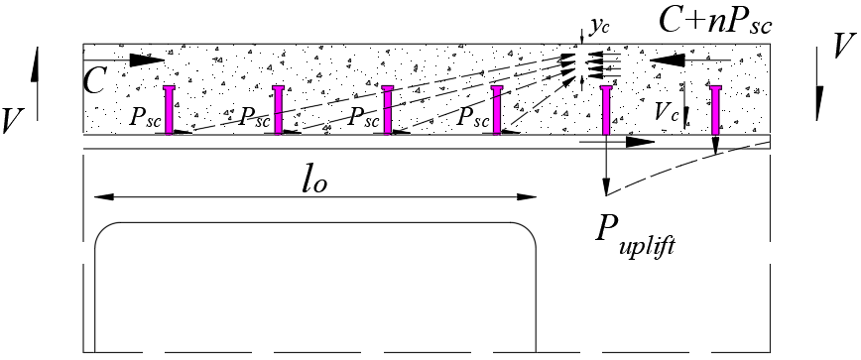
- Composite action (10pt)
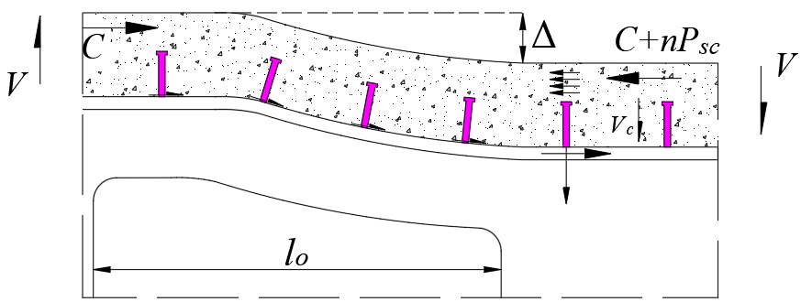
- Flexural effects along the span (10pt)
Fig. 1: Composite action between the top tee and concrete slab, adapted from Lawson and Hicks (2006)

As shown in Fig. 1 and in this paragraph, authors must leave one blank line between the figure and the following paragraph.

    - Equations
Equations must be typed using the MS Word equation editor, with a 12pt font, maintaining proportionality with the rest of the text. All symbols must be defined either before or after the equation. Equations should be placed in the text as close as possible to the sections to which they refer, left-aligned within the paragraph, and numbered sequentially, as in Eq. (01) below, which presents the calculation of the basic elastic critical moment (M_{cr,0}), where L is the beam length, E is the modulus of elasticity of steel, I_{y} is the moment of inertia about the weak axis, G is the shear modulus of elasticity of steel, J is the torsional constant, and C_{w} is the warping constant.
$$M_{cr,0}=\frac{π}{L}\sqrt{EI_{y}GJ+{\left(\frac{π}{L}\right)}^{2}EI_{y}EC_{w}}$$ | (01)
Previously, the symbols were presented before Eq. (01). However, the symbols can also be presented after the equation, as shown in the expression for the design axial resistance (Eq. 02), considering the yielding of the gross section:
$$N_{t,Rd}=\frac{A_{g}f_{y}}{γ_{a1}}$$ | (02)
Where A_{g} is the gross cross-sectional area of the member, f_{y} is the steel yield strength, and γ_{a1} is the safety factor, taken as 1.1.

- CONCLUSIONS
This section should present the conclusions corresponding to the conducted study.

REFERENCES
References must be typed in Arial font, size 12, with single line spacing, justified, arranged in alphabetical order, separated by 10pt spacing (before and after), and in accordance with the standards established by ABNT NBR 6023:2025, as shown in the examples below.
ASSOCIAÇÃO BRASILEIRA DE NORMAS TÉCNICAS. NBR 9062: Projeto e execução de estruturas de concreto pré-moldado. Rio de Janeiro, 2017.
BENITEZ, M. A.; DARWIN, D.; DONAHEY, R. C. Deflections of composite beams with web openings. Journal of Structural Engineering, v. 124, n. 10, p. 1139–1147, 1998.
DAS, P. K.; SRIMANI, S. L. Handbook for the design of castellated beams. New Delhi, Delhi, India: Oxford & IBH Publishing Company, 1984.
GUEZOULI, S.; LACHAL, A. Numerical analysis of frictional contact effects in push-out tests. Engineering Structures, v. 40, p. 39–50, 2012.

